Ontologies and The Semantic Web

CSE488



Course Project

Pharmacy Management System

|  |  |
| --- | --- |
| Abdelrahman Mohamed Shemies | 18P9565 |
| Ahmed Amr Behairy | 18P5837 |
| Daniel Tarek Lewis | 18P1185 |
| Mahmoud Mohasseb | 20P2787 |

1. *Ontology*

### Product Perspective

The product to be developed in our report is a Pharmacy management system, where the customer can order medicine, have alternatives for the medicine if it is not found or our pharmacist can suggest a medicine according to his/her medical case.

According to the users of our system which are the pharmacist, The manager and The cashier. The system supports the ability to track the inventory levels, data of working employees and the salaries of these employees all by the aid of database.

The system can be developed to be used in a hospital management business where medicine management is necessary Or it can developed for a pharmacy business on its own.

### General Capabilities

The system will provide our users an easy, professional way to track the medicine management, employees’ management and the inventory levels with its interactions with the suppliers. It helps the users interact with the customer easier and faster with making the selling process in a more efficient way.

The system makes the pharmacist enters all the medicine data with its expiry dates, its uses, its price and precautions to be saved so it can easily be accessed when needed for either the selling process or checking the inventory levels.

For the cashier using, the system helps when selling process occurs where he takes the customer info to be easily accessed in later selling processes and then confirms the payment method defined by the customer to proceed the selling process successfully.

And finally, for the manager using, the system helps a lot in saving all the employees’ working data, calculating their working hours and therefore calculating their salaries.

Our System helps in managing and documenting this amount of data to be easily accessed for further procedures when using it, all these data can be outputted as reports to the users.

### General Constraints

Our system constraints mainly depend on the current used computer operating capacity so, if running another application with our system could overload it or require additional hardware. This involves financial considerations to accommodate technical improvements.

### User Characteristics

For the pharmacist, he has the access of mainly the medicine management, so he must have the background of dealing with drugs and medicine so that he can add their data to the system in a professional way, but for the cashier, he only deals with the selling process and therefore he must have the background of finance and the ability to deal with the various payment methods that may be chosen by the customer, For the manager of the pharmacy he do the whole management of the employees with their data. The customer has no access on our system as he only does the ordering process via the previously mentioned users of the system. But his information is entered and saved to the system.

### Environment Description

The System should be implemented for the usage of the manager and the employees in the pharmacy including the pharmacist and the cashier.

This interface will be set up on a normal computer considering all the functionalities of the system for this computer to be capable of the word load of the various users, and to be able to be connected to the database for storing and getting the various information entered by the users.

### Assumptions and Dependencies

Our system is managed to sell medicine according to the desire of the customer, therefore, the medicine information entered to the system by the pharmacist should be entered correctly, professionally and with all the details. This to avoid any mistakes in the selling procedure for the customer satisfaction.

Also the data of the employees’ working should be entered correctly and continuously be updated by the manager, for the further procedures dealing with these information to be done correctly.

Careful dealing with the data entry to the system should take place, to apply all the functionalities efficiently and to avoid failures, all for the customer satisfaction.

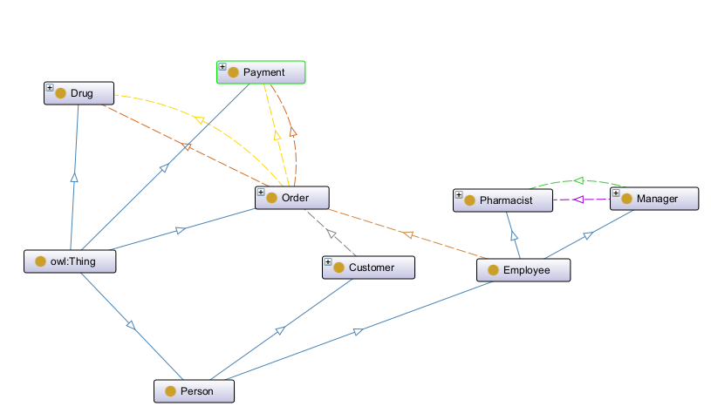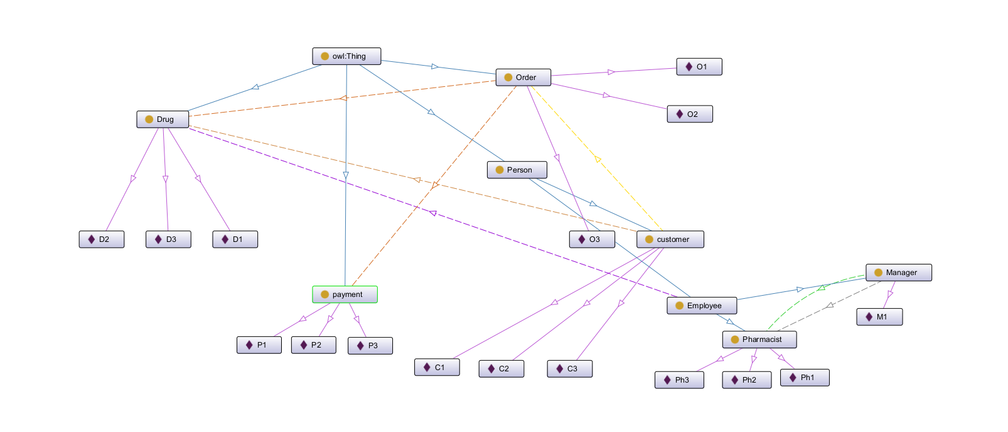

1. *RDF*

**Entities**

* Person subclass of thing
* Drug a subclass of thing
* Payment subclass of thing
* Order subclass of thing
* Employee a subclass of person
* Customer a subclass of person
* Pharmacist subclass of person a subclass of employee
* Manager a subclass of employee

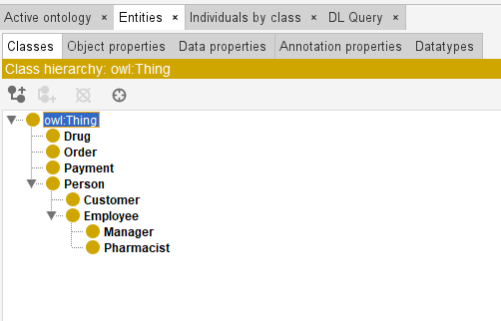

**Object Properties**

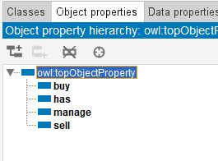

* Buy (Customer buy Order)
* Has (Order has Drug & Order has Payment)
* Manage (Manger manage Pharmacist)
* Sell (Pharmacist sell order)

**Data Properties**

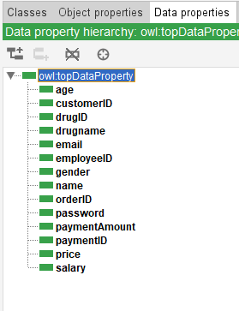

* Age
* customerID
* drugID
* drugname
* email
* employeeID
* gender
* name
* orderID
* password
* paymentAmount
* paymentID
* price
* salary

**Constraints**

* Order has min 1 drug
* Order has only one Payment
* 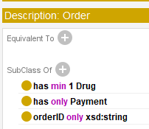
* Customer buy min 1 order
* 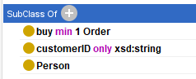
* Manager manage min 1 Pharmacist
* Manager manage max 5 Pharmacist
* 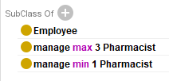

1. *Instances*

Drug

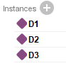

Order

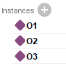

Payment

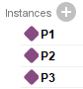

Person:-

Customer

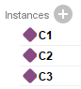

Manager



Pharmacist

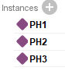

1. *SparQL Queries*
2. 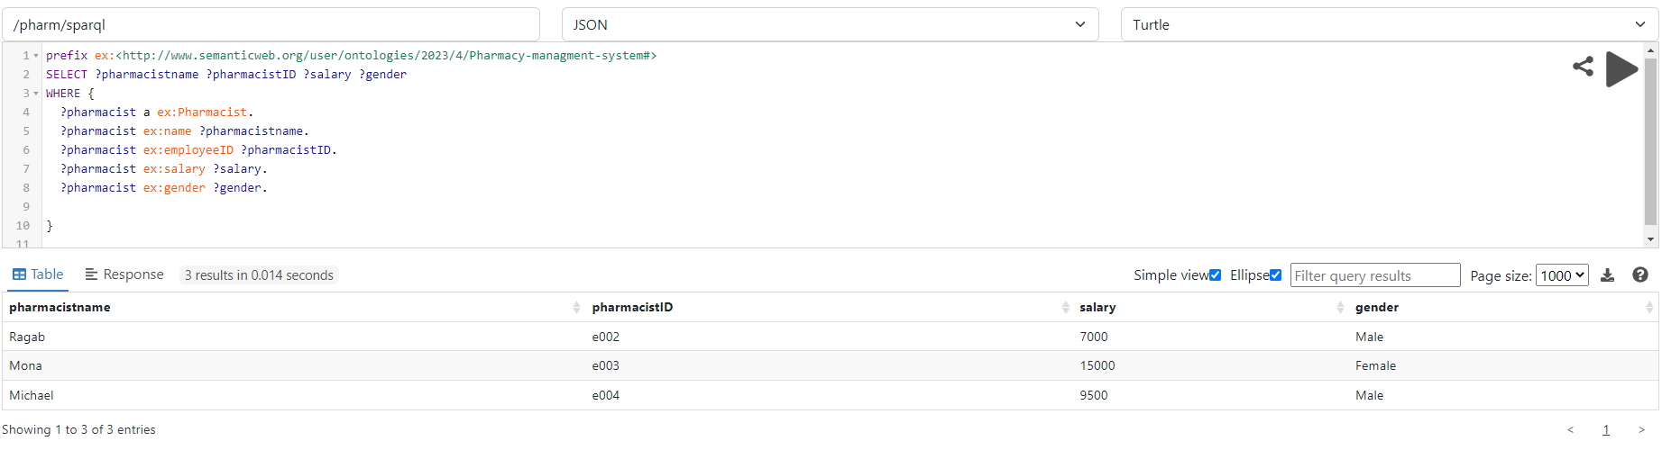List all Pharmacists Listing their name , ID, Salary, and Gender
3. 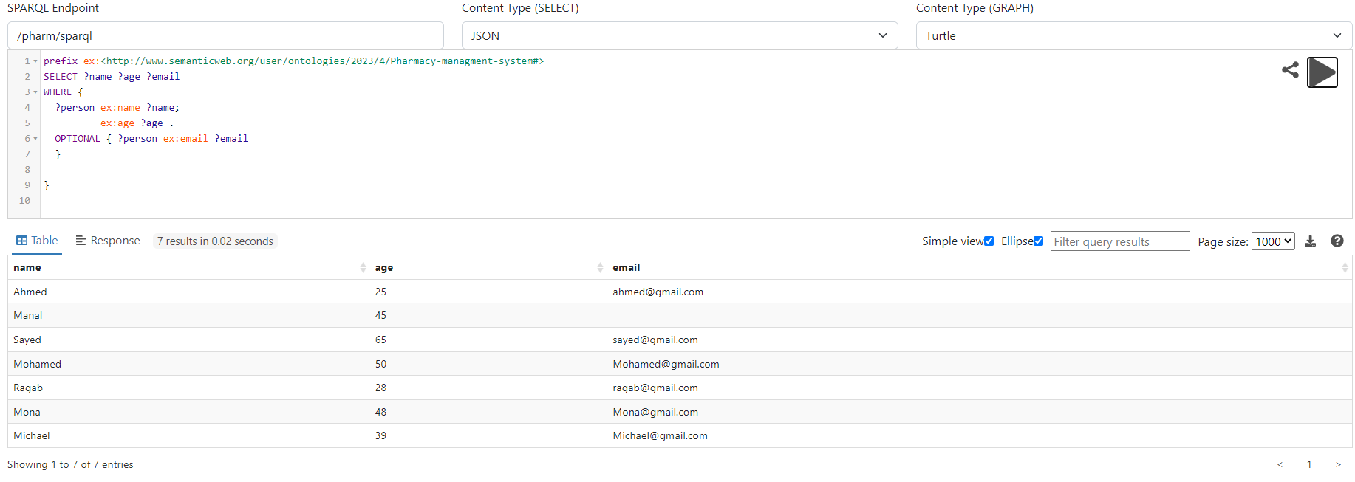List all persons listing their name , age and email (Optional)
4. 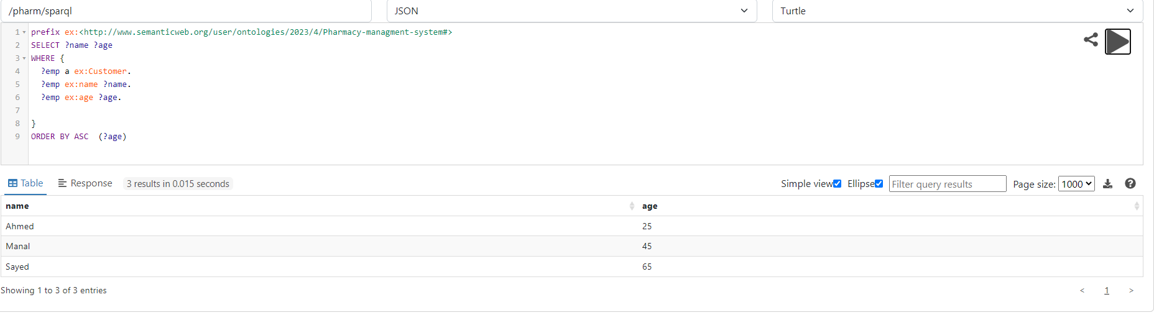List all customers and arranging them ascendingly by age
5. 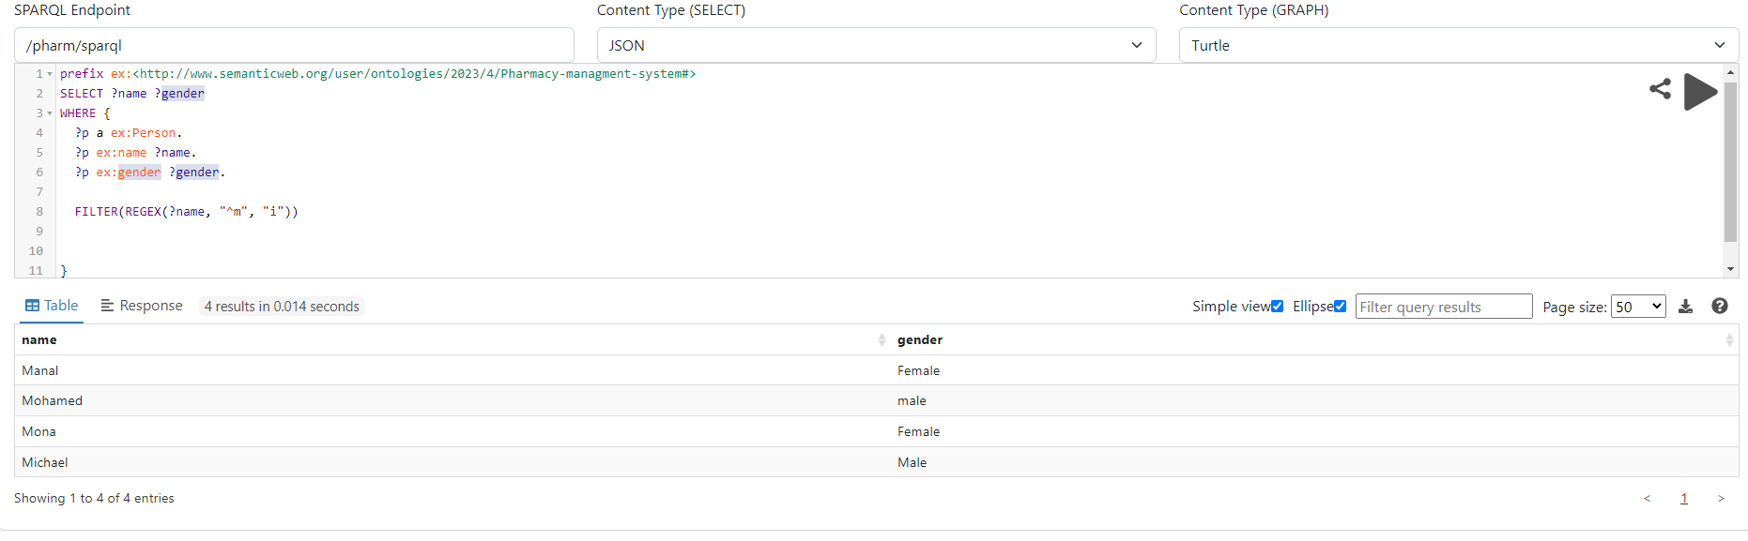List all persons who starts with letter m (regex and filter) and their gender
6. 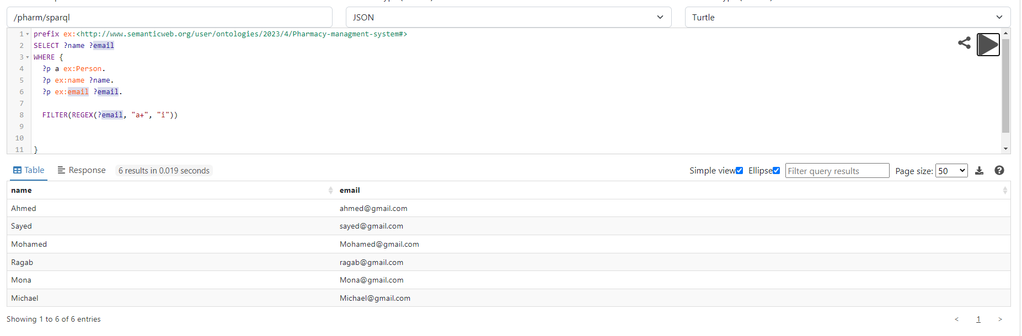List all persons who have emails that include letter a (regex and filter) and their names
7. List all the Payments that have their amounts >450 UNION <300

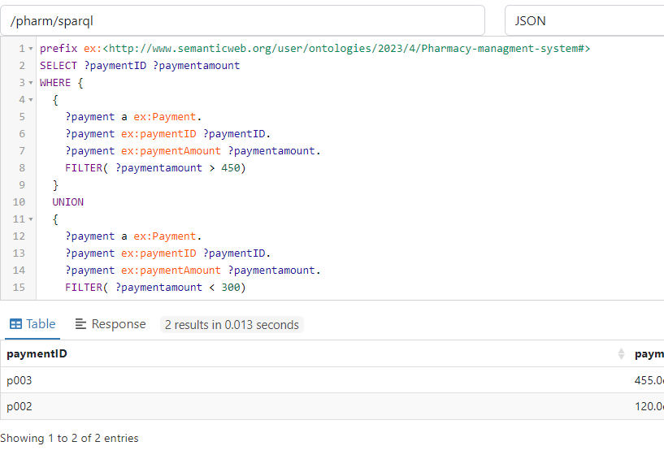

1. 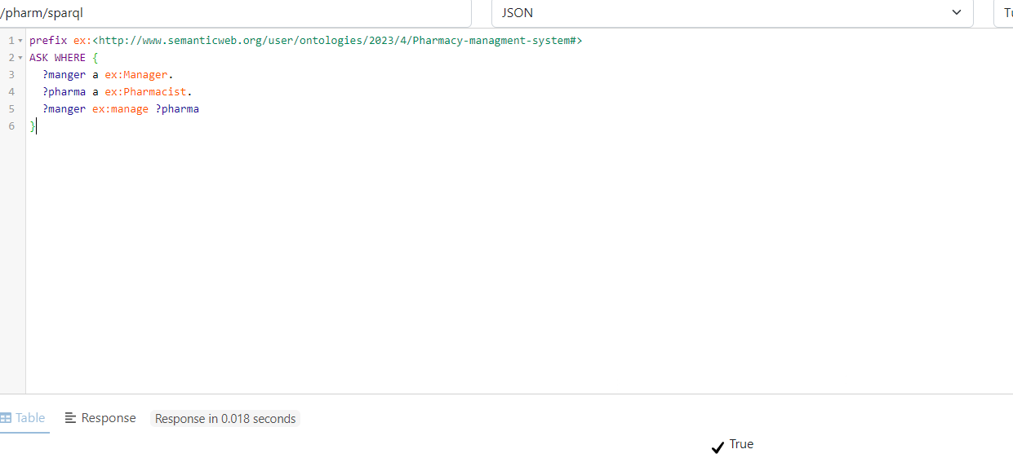ASK if there is a manager who manage pharmacist
2. 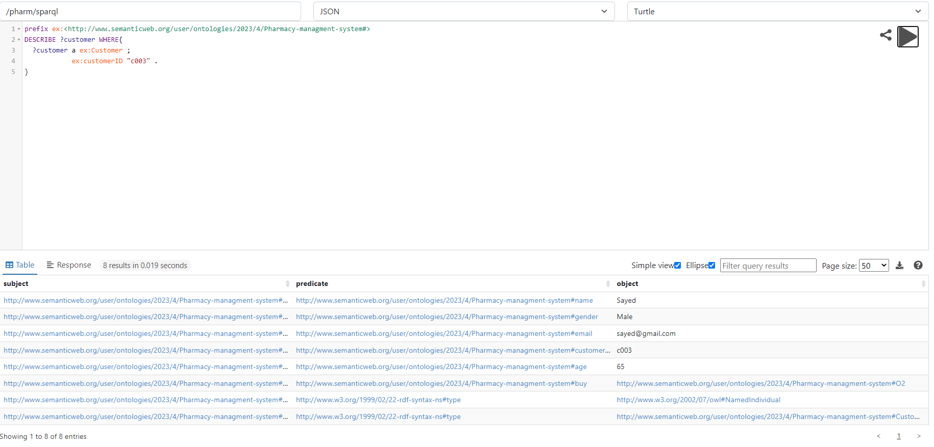List all description of all orders that contain customer with customerID “c003”
3. 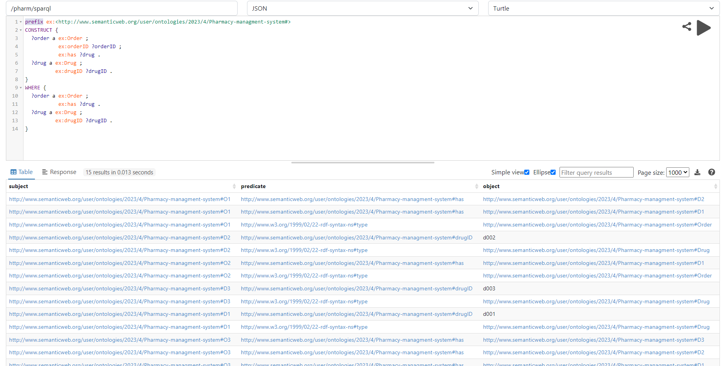Construct a result set containing all orders and the drugs they contain.
4. 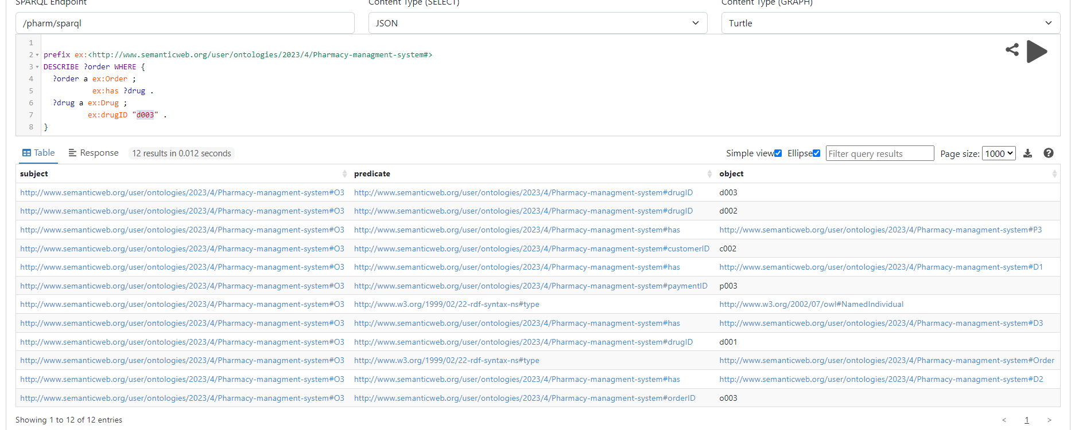Obtain a description of all orders that contain a drug with drug ID "d456".
5. *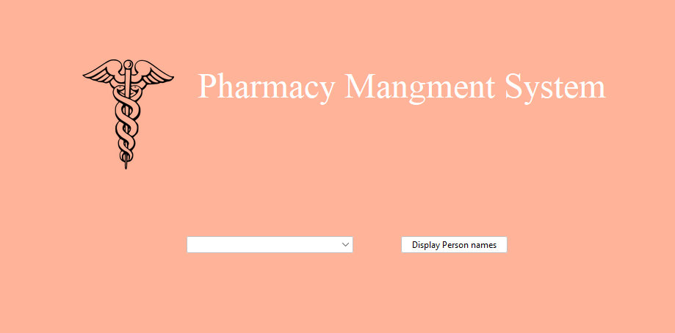Front END*